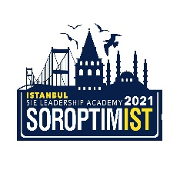


SOROPTIMIST INTERNATIONAL OF EUROPE
VIRTUAL LEADERSHIP ACADEMY
JULY 5 2021 – JULY 10 2021, SI TURKEY
APPLICATION FORM FOR GUESTS

*Monday July5, Opening Day, Saturday July10, Closing Day attendance available between 09.30-16.00 (CEST)
*Tuesday until Friday attendance available between 13.15-16.00 (CEST)
Personal Data
Name in full: (Last name, First name)
Date of birth:
Place of residence (Country):

PRESENT STATUS
STUDENT:
FACULTY /DEPARTMENT /GRADE :
Undergraduate / Postgraduate / Doctorate

EMPLOYED:
Educational background:
Occupation:
Telephone/Mobile: E-mail:

SOROPTIMIST UNION / CLUB CONNECTION
ARE YOU A SOROPTIMIST?
IF YES, PLEASE INDICATE
A-) NAME OF CLUB /UNION :
B-) NAME OF SINGLE CLUB :
IF YOU ARE NOT A SOROPTIMIST
How did you hear about the SIE LA 2021?
A-) WEB PAGE
B-) A SOROPTIMIST
C-) OTHER
Please briefly indicate the reason(s) why you are interested in attending the LA? (max.50 words)

